**TASK-4**

**Automate Assignment below task using GitHub action.**

1. **Build Docker Image**

STEP 1: - Install requirements.txt file with command < pip install -r requirements.txt >

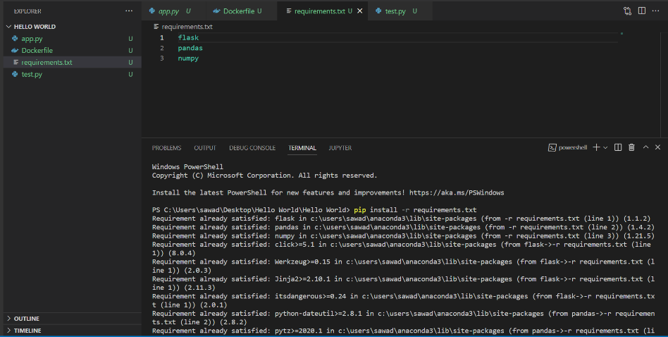

STEP 2: - Run python app.py file with command < python app.py >

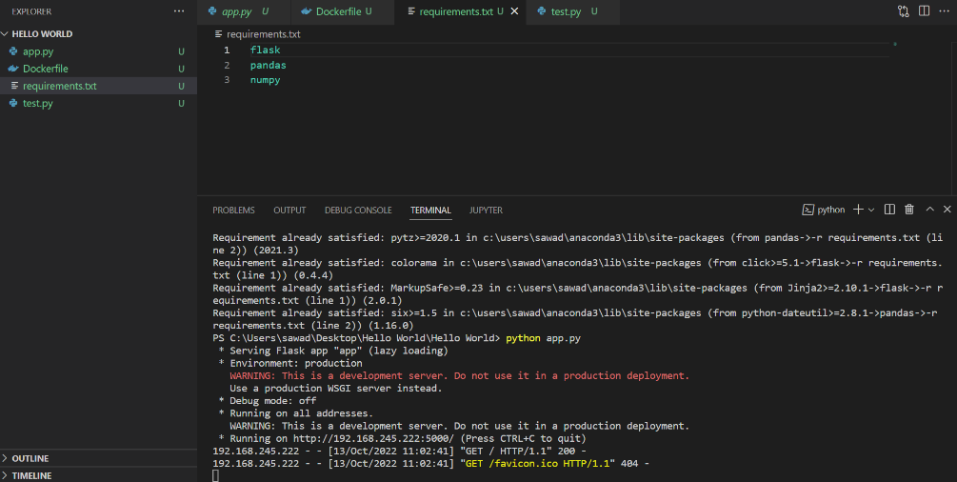

STEP 3: - Click on output URL and open in new tab just like following image.

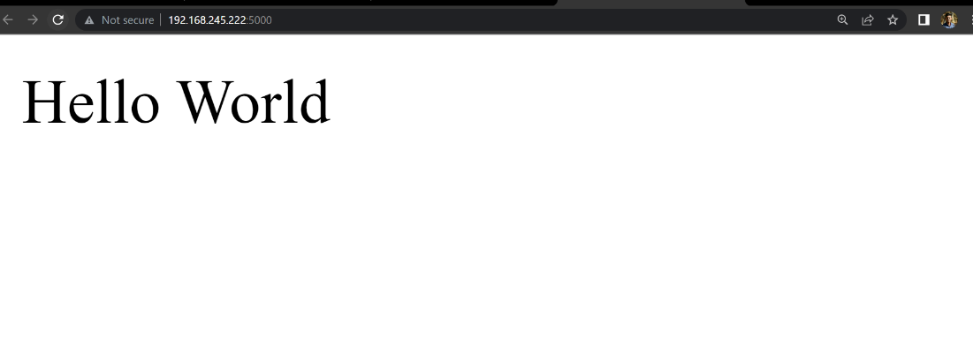

STEP 4: - Download welcome app with command < docker build -t welcome-app . >



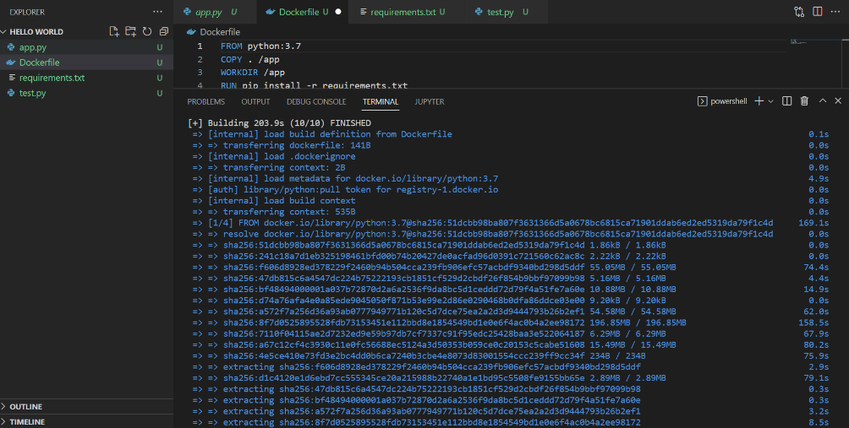

STEP 4: - **Check docker image with command < docker images >**

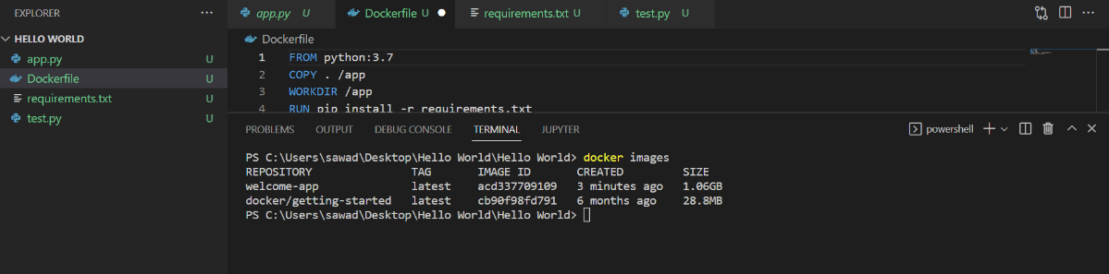

STEP 5: - **Check docker images in docker desktop app**

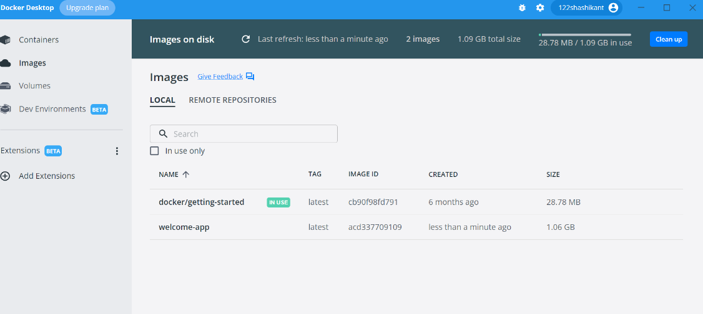

STEP 6: - Run docker container in locally with command < docker run -d -p 5000:5000 welcome-app

First 5000 is assigned port number

Second 5000 is container port number

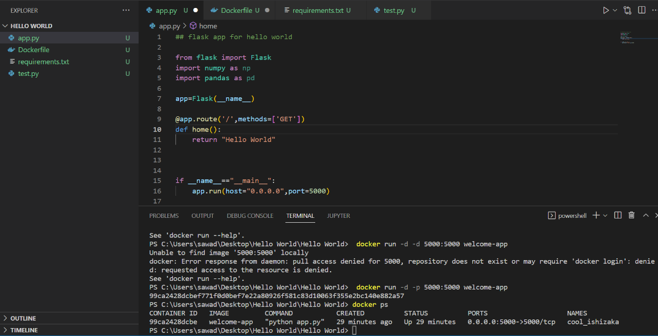

STEP 7: - Run in new tab with local host id with assigned port number after like 127.0.0.1:5000

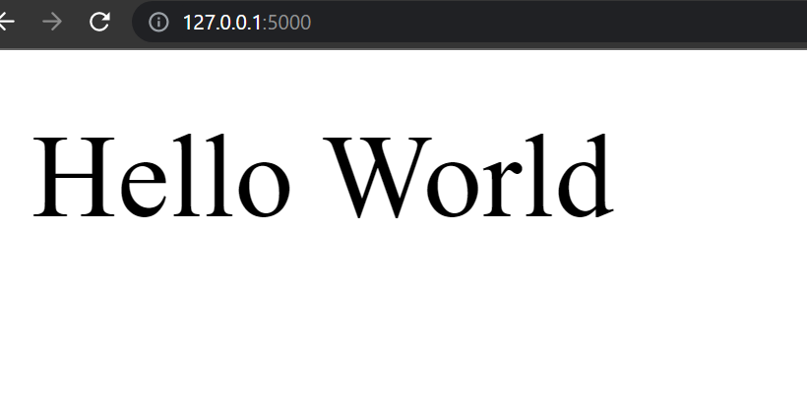

1. **Push Docker Image to Docker hub.**

**STEP 1: - Build docker image in docker hub profile with command**

**< docker build -t 122shashikant/welcomeapp . >**

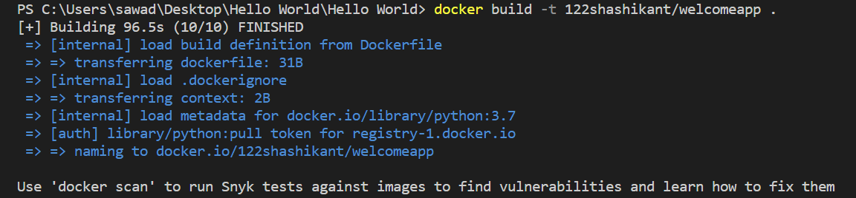

**STEP 2: - Check docker images with command < docker images >**

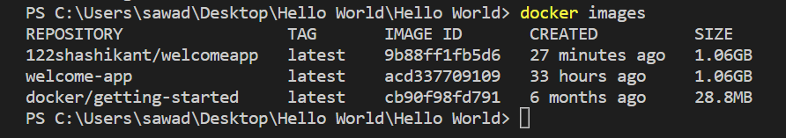

**STEP 3: - Push the image in docker hub with command < docker push 122shashikant/welcomeapp:latest >**

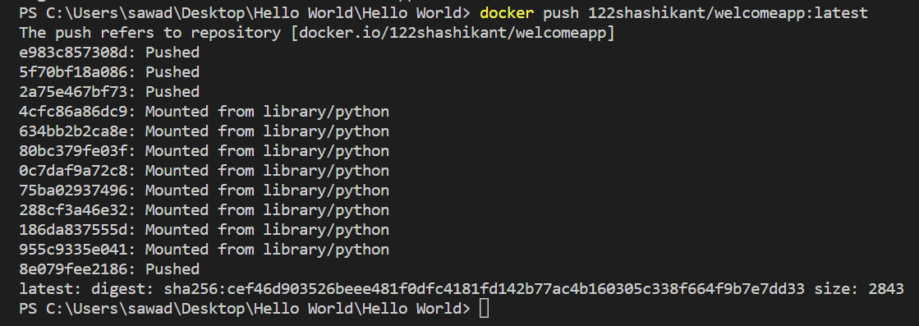

**STEP 4: - Check push images in docker hub to go to docker hub pages and check**

